LLM-RAG based startup idea feasibility and market validation engine:

In this project we are employing LLM-RAG (Large Language Model with Retrieval-Augmented Generation) to analyze a startup idea and evaluate its feasibility using market evidence, customer pain points, competition, market gaps and technical feasibility. The system accepts a startup idea from the user and retrieves relevant evidence to generate an overall validation score, validation status and evidence-based recommendation. The application is developed using Python 3.11.9 and provides a web-based interface for entering startup ideas and viewing detailed validation results.
The system uses a Gemini API key to perform LLM-based analysis. The API key is generated from Google AI Studio and configured in the .env file before running the application.
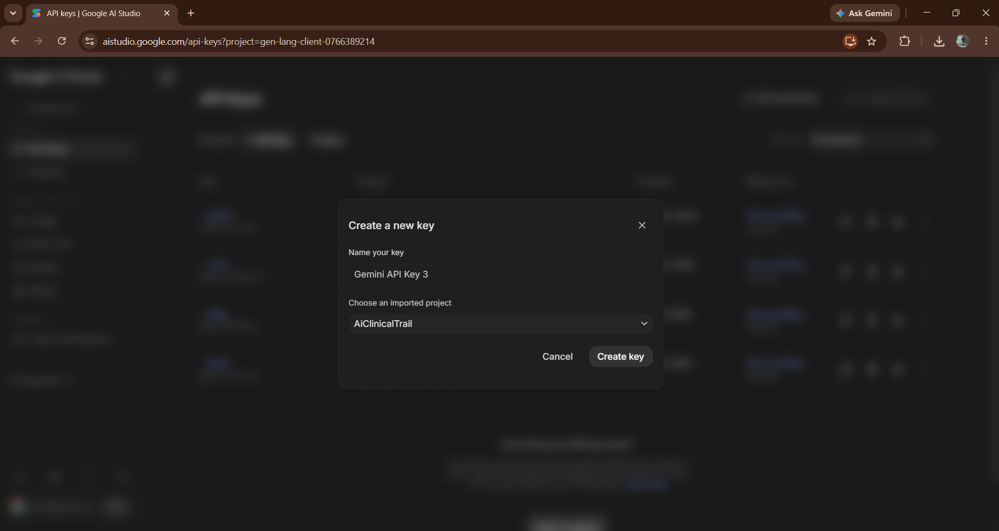
In above screen we have created a new Gemini API key by providing the key name and selecting the required project. After clicking on Create key, the API key is generated for the application.
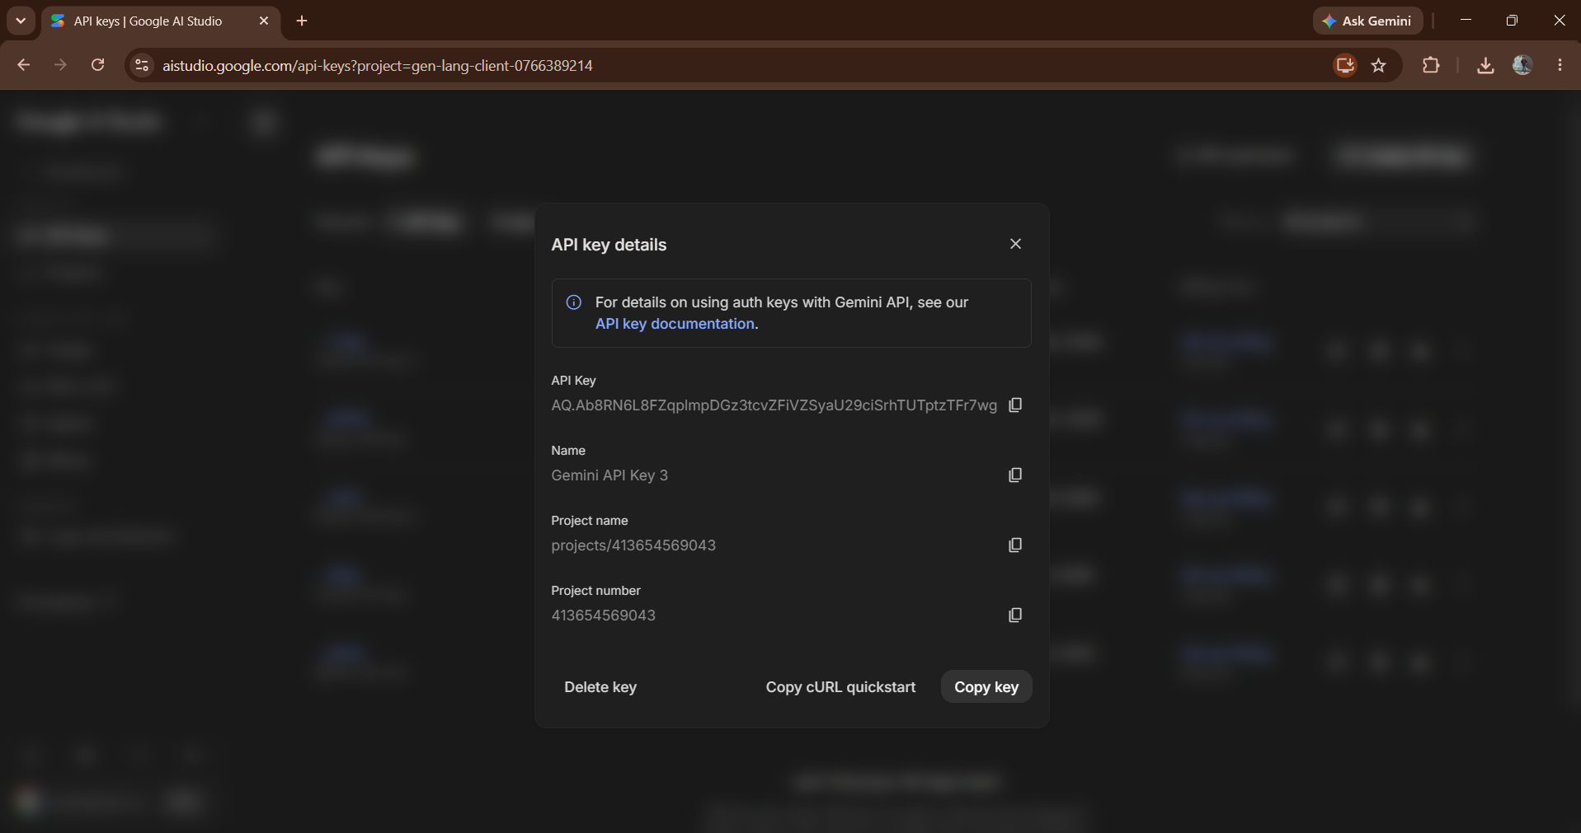
In above screen the generated API key details are displayed, including the API key, key name, project name and project number. The generated API key is copied and placed inside the project's .env file so that the application can securely access the Gemini API.
To implement this project we have designed following modules:
- Startup Idea Input Module: using this module the user will enter a startup idea into the application and submit it for feasibility and market validation.
- LLM-RAG Analysis Module: using this module the submitted startup idea will be processed through the LLM-RAG pipeline to retrieve relevant information and generate evidence-based analysis.
- Market Analysis Module: using this module the system will identify the target market, relevant market problems, market evidence and supporting sources related to the submitted startup idea.
- Customer Pain Analysis Module: using this module the system will identify customer pain points, pain categories, severity and supporting evidence associated with the target market.
- Competition Analysis Module: using this module the system will analyze the competitive landscape, identify available competitors and determine the level of competitive evidence.
- Market Gap Analysis Module: using this module the system will identify unresolved problems and potential gaps in the existing market based on retrieved evidence.
- Technical Feasibility Module: using this module the system will evaluate technical requirements, technical signals, technical risks and the feasibility of implementing the proposed startup idea.
- Validation Score Module: using this module the system will calculate and display the overall validation score based on different dimensions such as market evidence, customer pain, competition, market gap and technical feasibility.
- Final Validation Report Module: using this module the system will generate a consolidated report containing the startup idea summary, target market, customer pain points, market evidence, validation score, evidence-based recommendation and evidence limitations.

SCREENSHOTS:
To run the project, double click on run.bat button to start the server and open the application.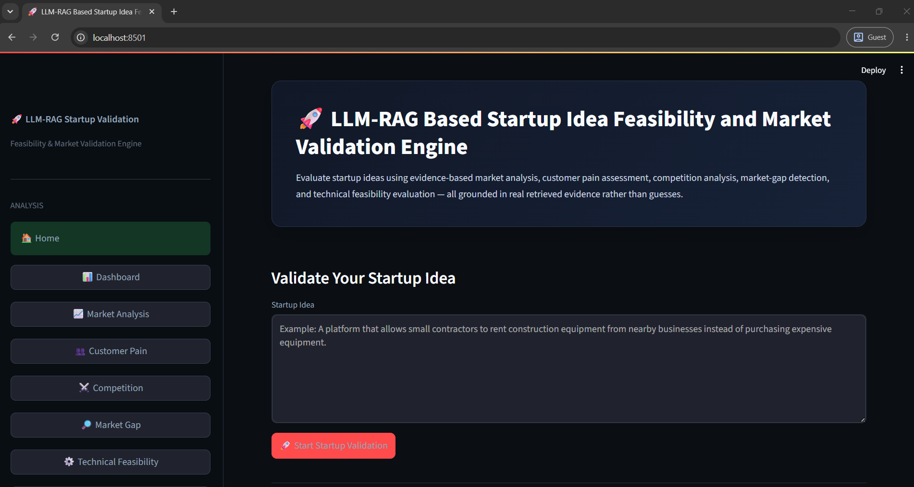
In the above screen the LLM-RAG Based Startup Idea Feasibility and Market Validation Engine home page is displayed. The user can enter a startup idea in the provided text area and click on the Start Validation button to analyze the startup idea.
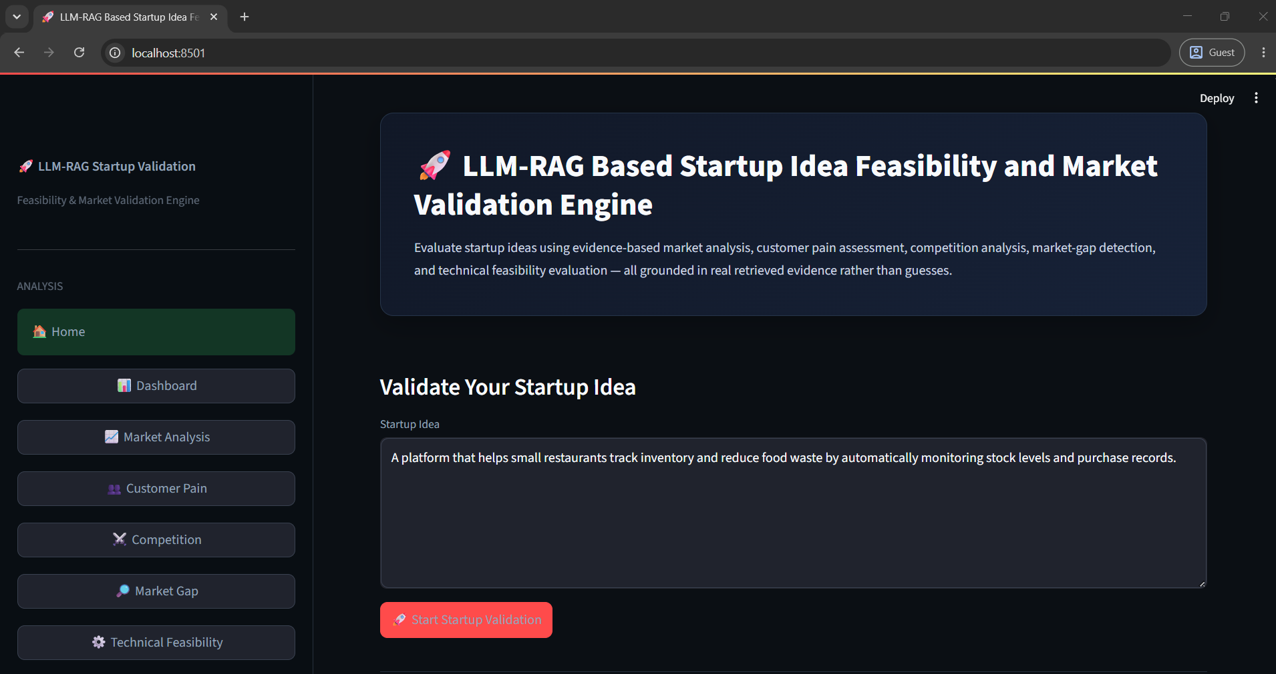
In the above screen another startup idea is entered in the Validate Your Startup Idea section and the user can start the validation process to generate market and feasibility analysis.
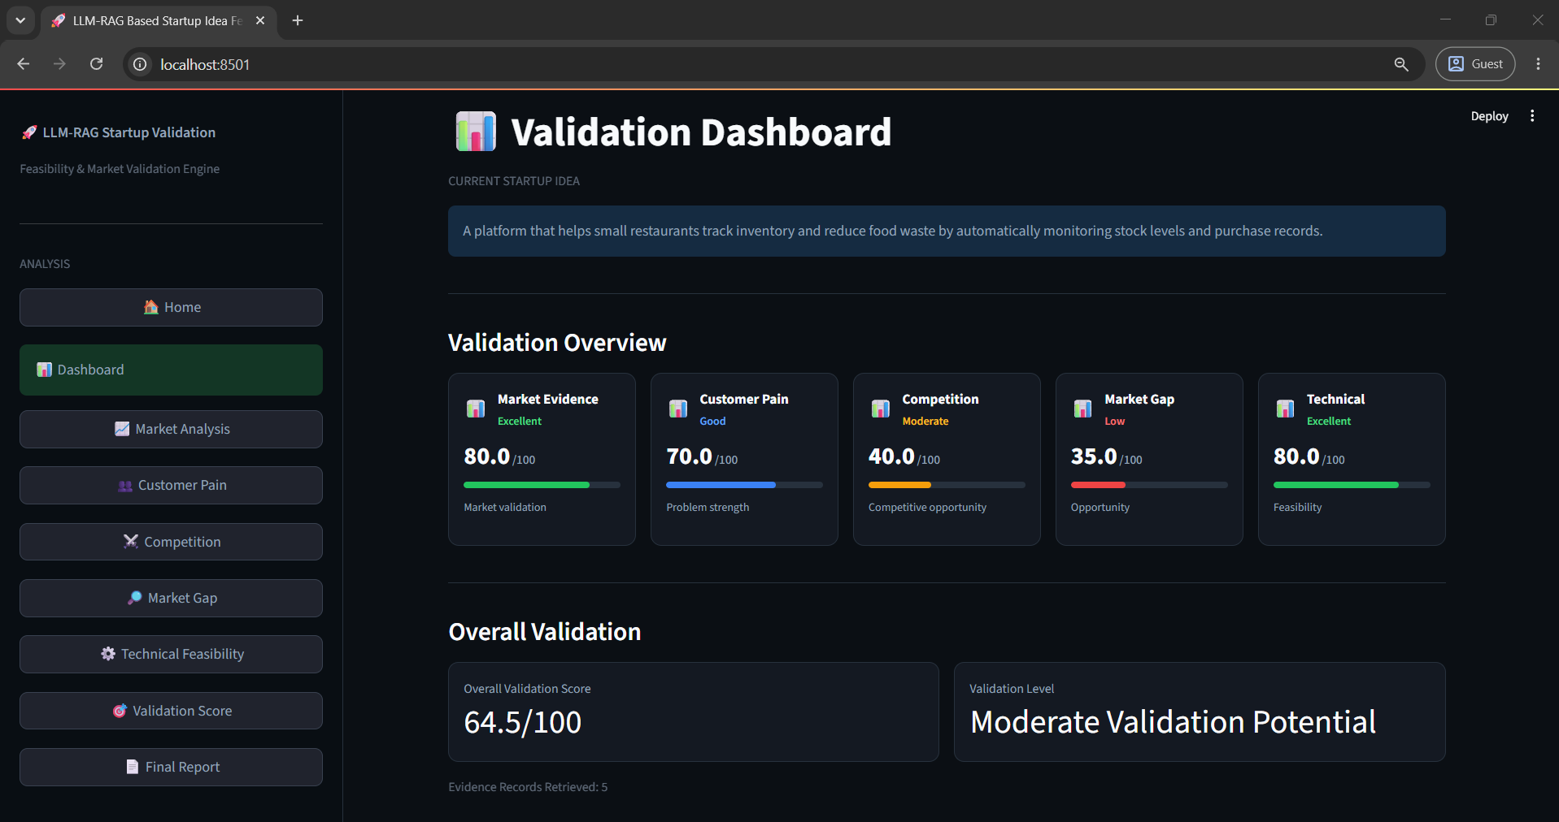
In the above screen the Validation Dashboard displays the overall startup validation results. It shows different validation dimensions such as Market Evidence, Customer Pain, Competition, Market Gap and Technical Feasibility, along with their individual scores and an overall validation score.
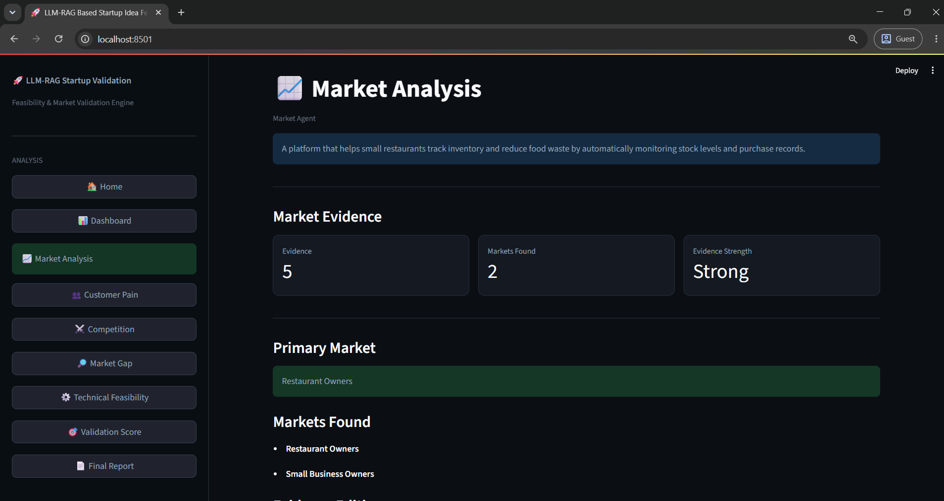
In the above screen the Market Analysis page displays market evidence identified for the submitted startup idea. It shows the number of evidence items, market sources and evidence strength, along with the identified primary market and markets found.
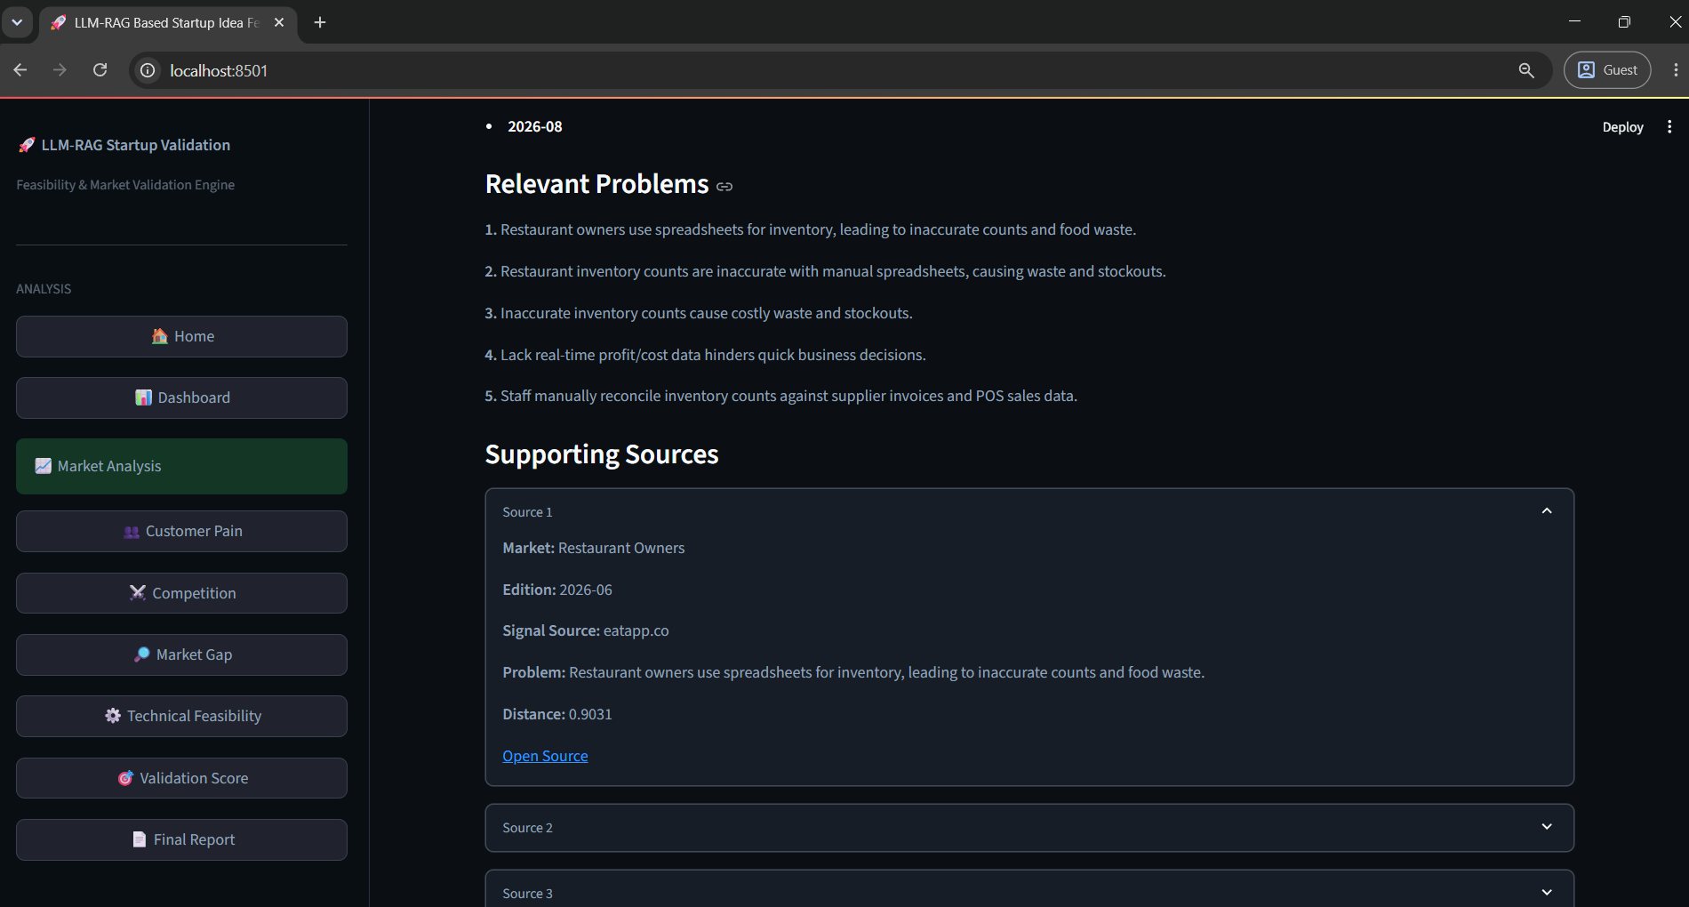
In the above screen the system displays Relevant Problems and Supporting Sources identified through the RAG-based analysis. The user can expand the available source sections to view the supporting evidence used for validation.
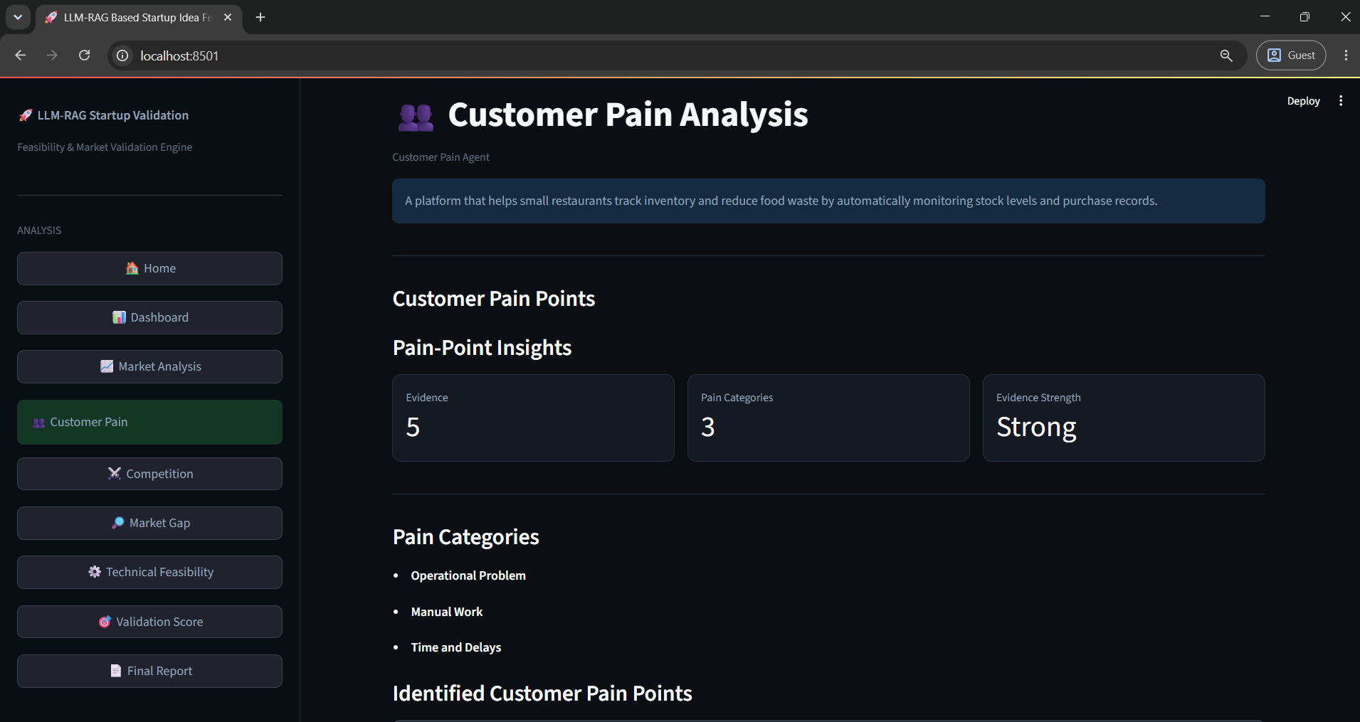
In the above screen the Customer Pain Analysis page displays identified customer pain points. It provides pain-point insights including the number of pain points, average severity and evidence strength, along with different pain categories.
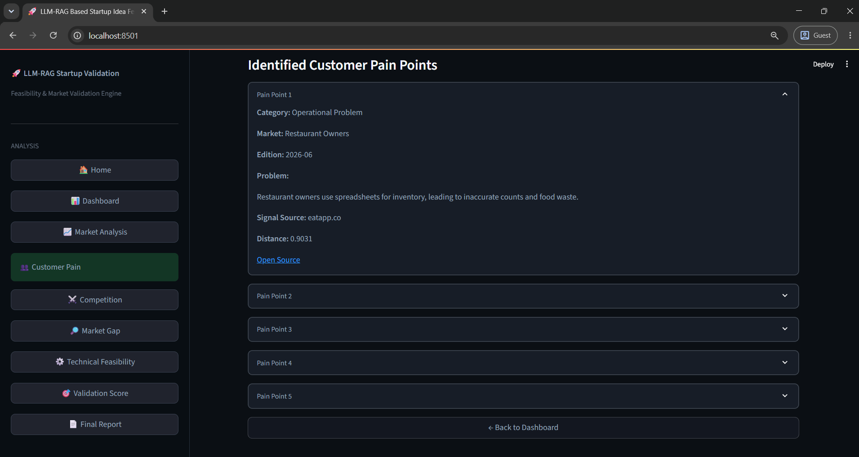
In the above screen the system displays the Identified Customer Pain Points in expandable sections. Each section provides details such as the category, market evidence, problem description and supporting source information.
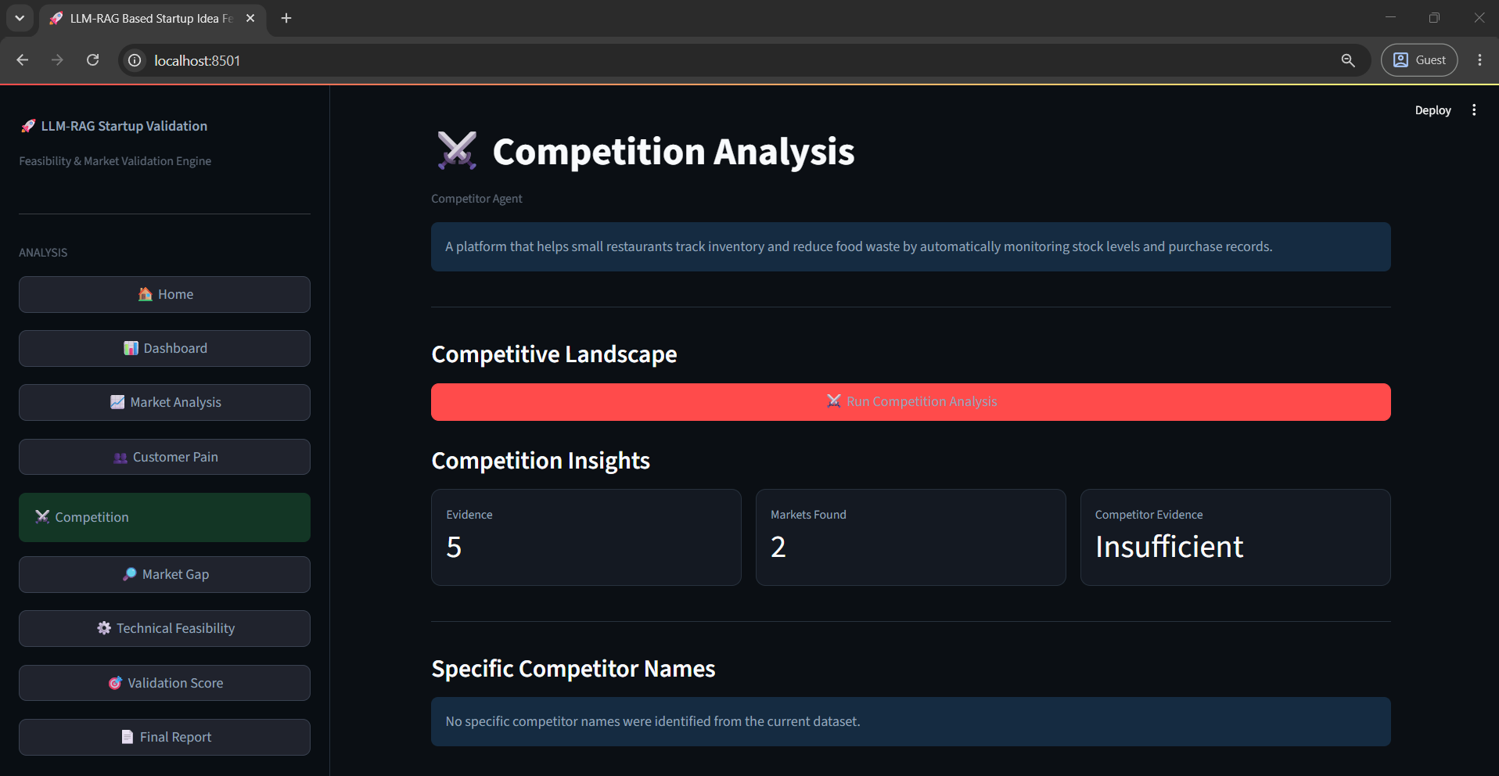
In the above screen the Competition Analysis page displays the competitive landscape and competition insights. It shows the number of competitors, market level and competitive strength, along with specific competitor information when available.
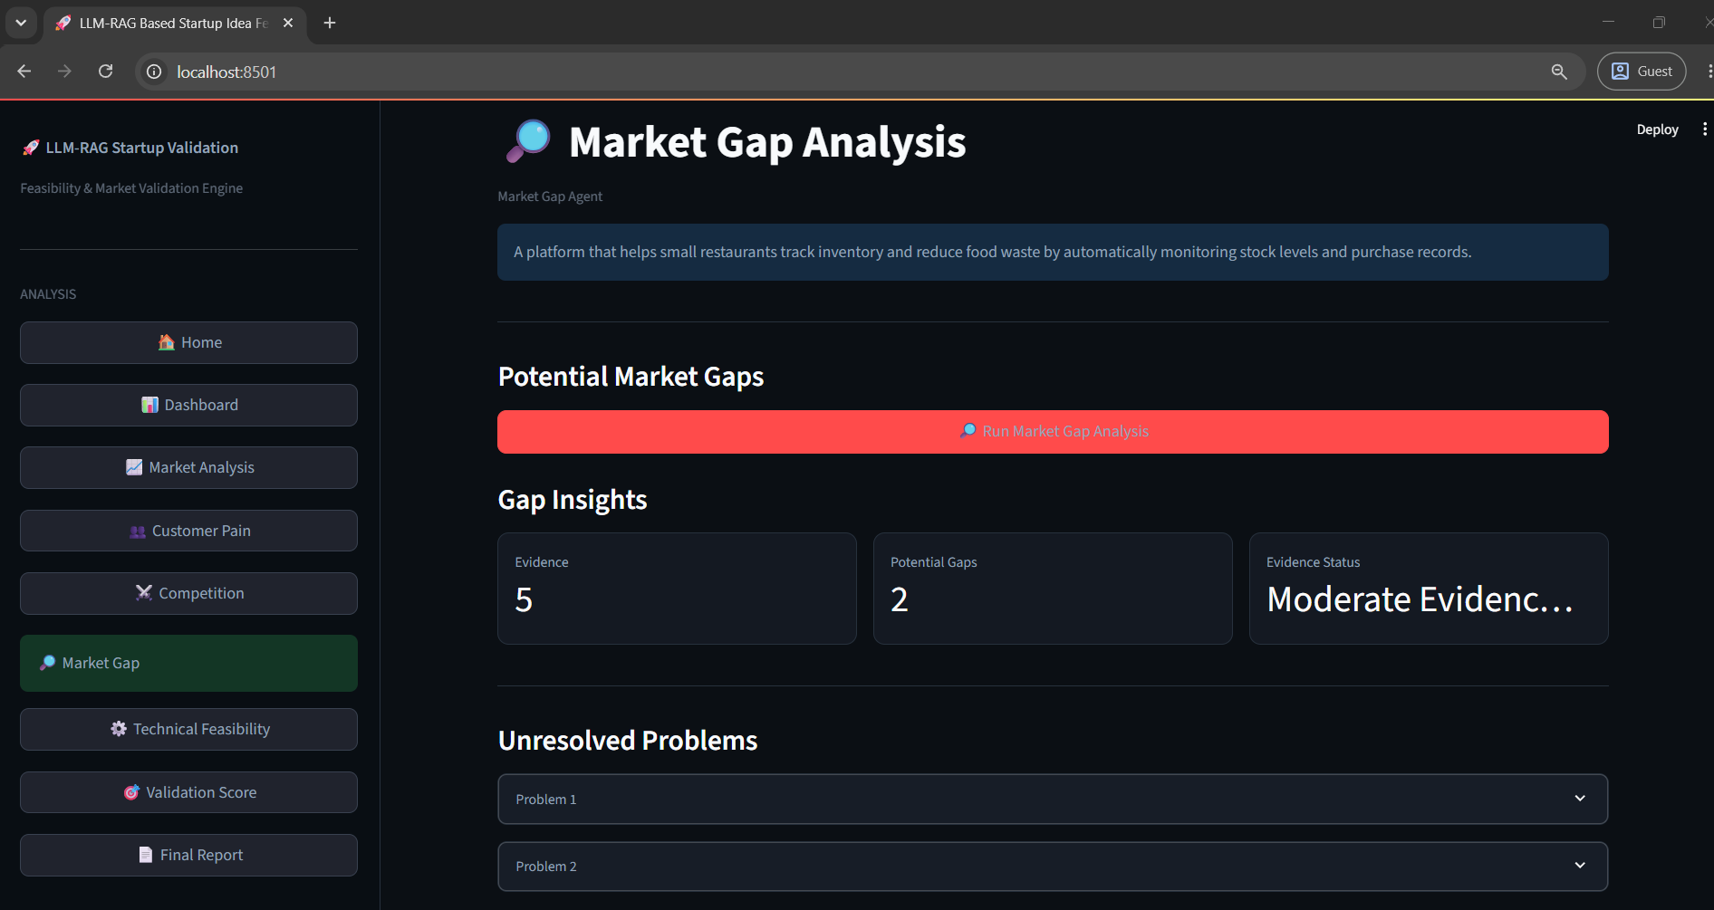
In the above screen the Market Gap Analysis page identifies potential gaps in the target market. It displays gap insights including the number of gaps, evidence level and evidence strength, followed by unresolved problems related to the startup idea.
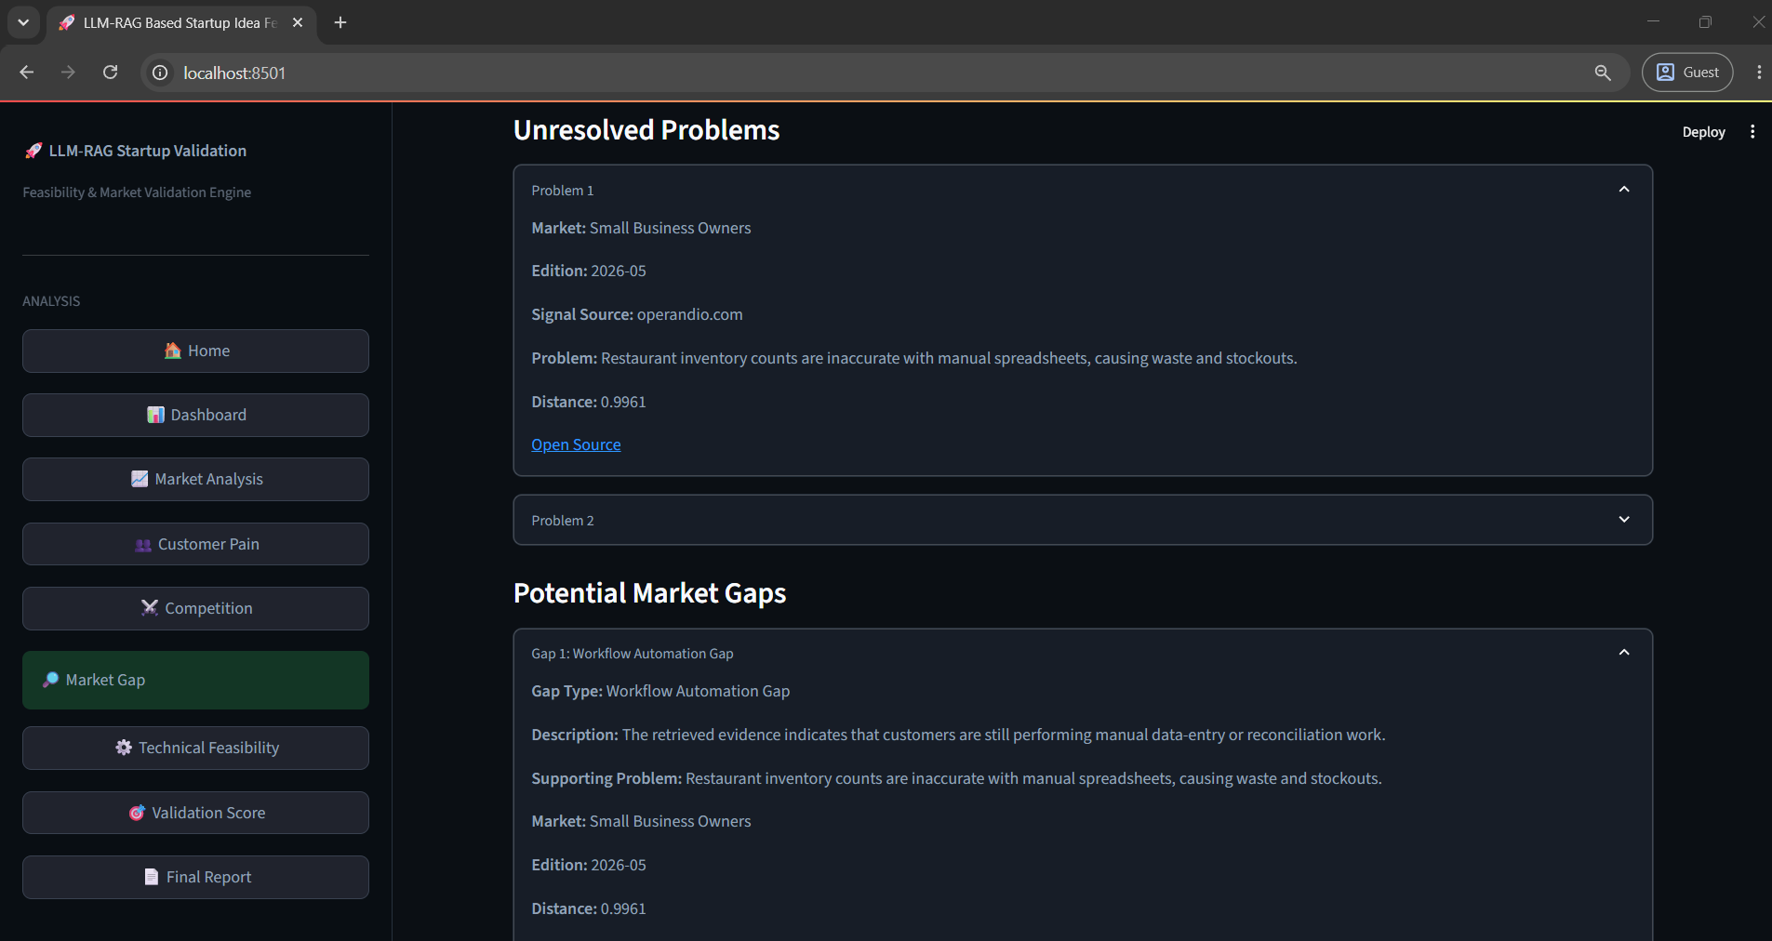
In the above screen the system displays detailed Unresolved Problems and Potential Market Gaps. The expandable sections provide descriptions of identified problems, market evidence, source information and the corresponding opportunity areas.
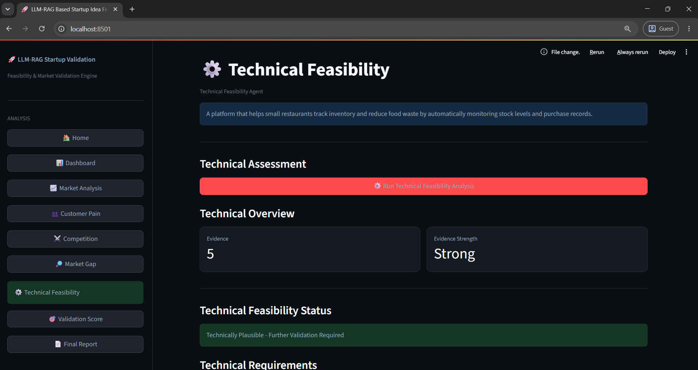
In the above screen the Technical Feasibility page presents the technical assessment of the startup idea. It displays technical overview information, evidence strength and the technical feasibility status of the proposed idea.
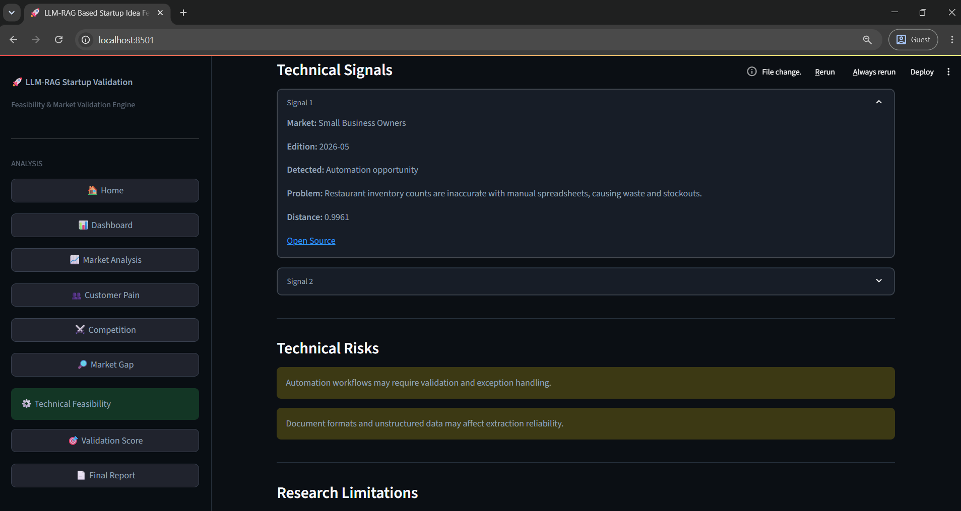
In the above screen the system displays Technical Signals, Technical Risks and research-related limitations. The technical signals provide supporting evidence, while the highlighted risk sections show potential technical concerns identified during analysis.
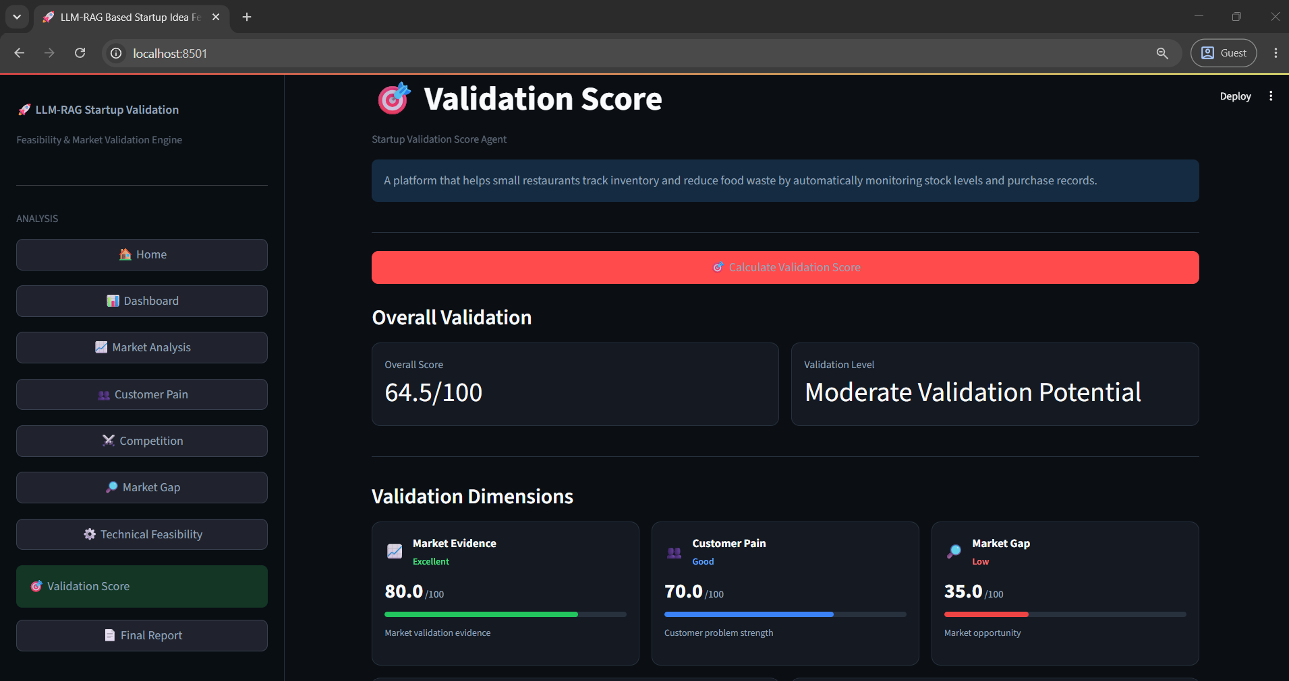
In the above screen the Validation Score page displays the overall validation score and validation potential. It also presents individual validation dimensions such as Market Evidence, Customer Pain and Market Gap with their respective scores.
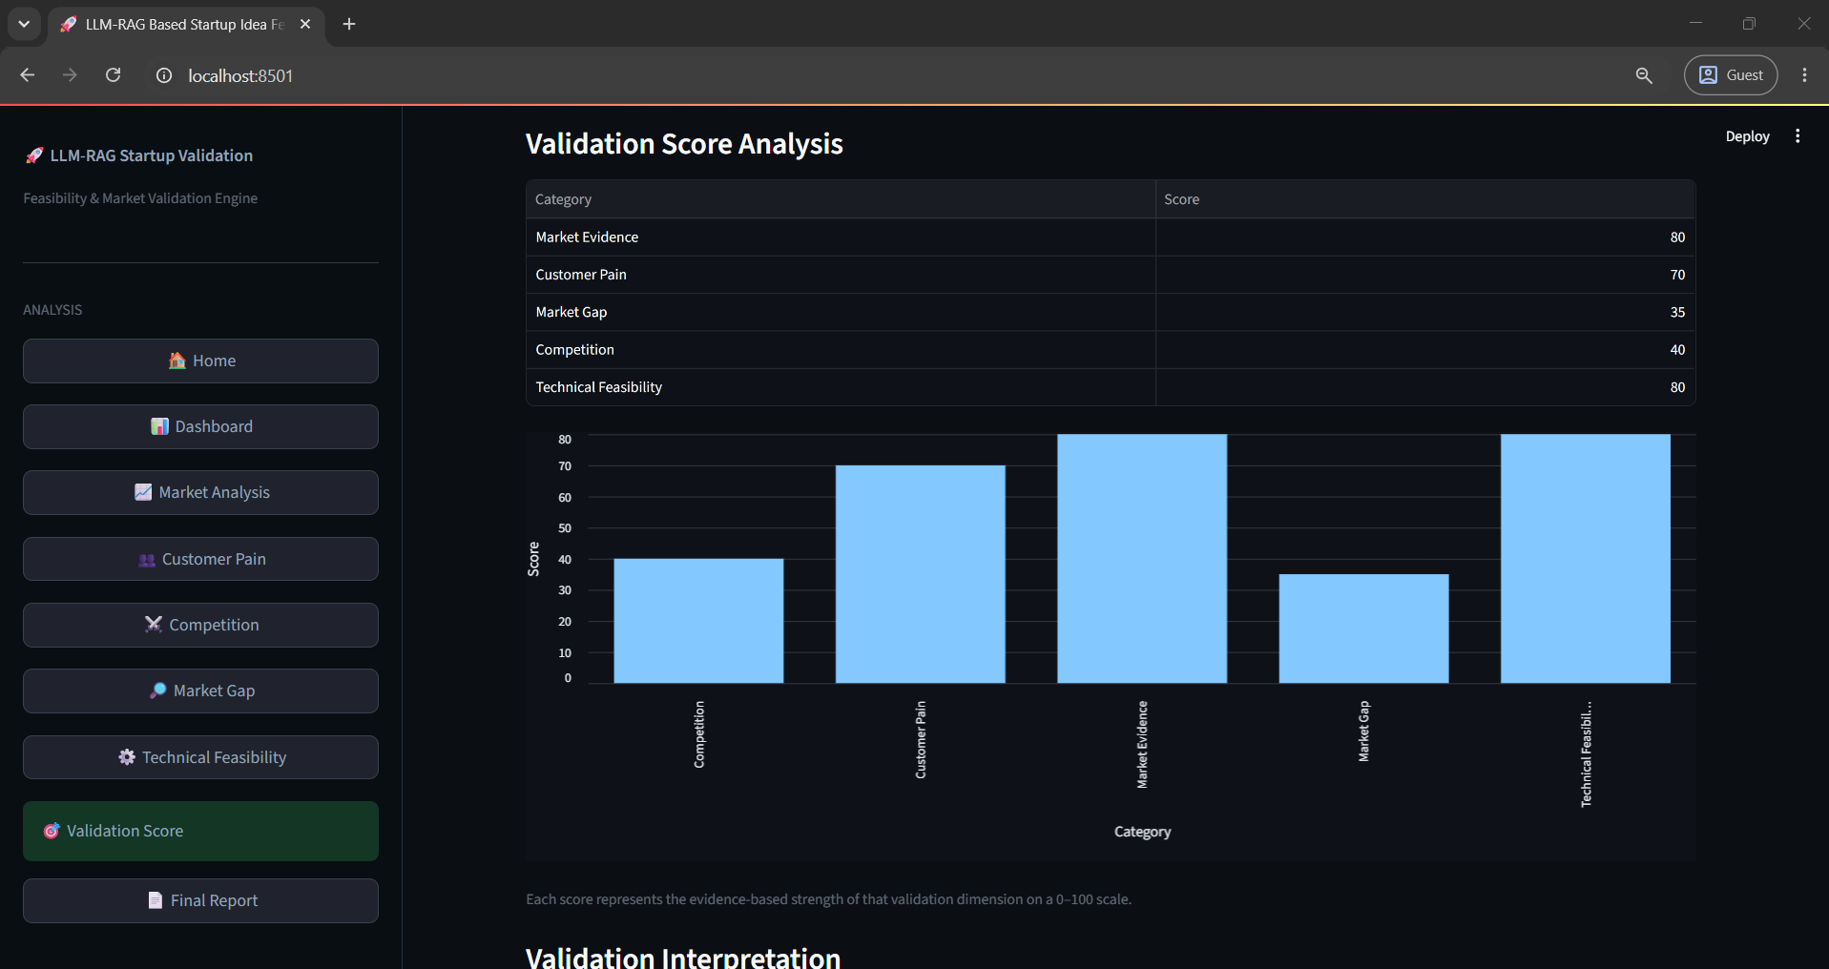
In the above screen the Validation Score Analysis displays a graphical comparison of the different validation dimensions. The bar chart provides a visual representation of the scores obtained for the startup idea.
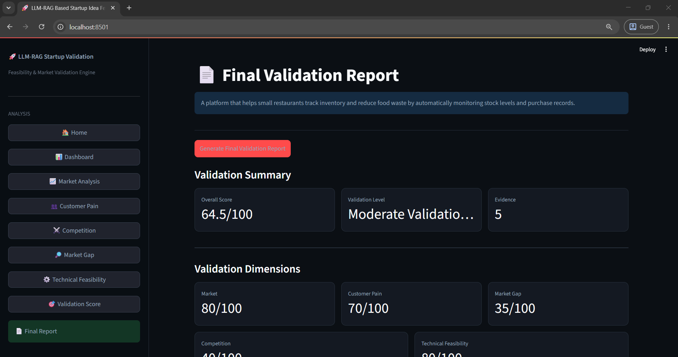
In the above screen the Final Validation Report provides a consolidated summary of the startup analysis. It displays the overall score, validation status and number of identified items along with individual validation dimension scores.
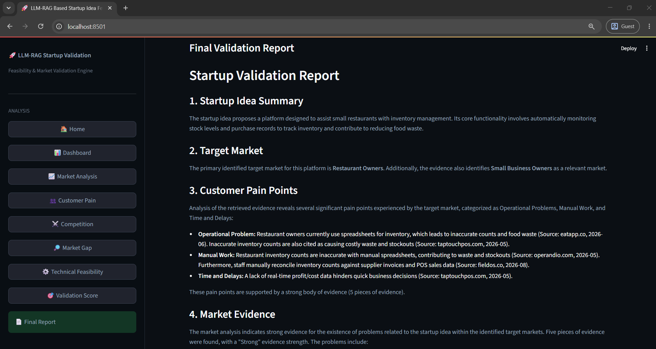
In the above screen the Startup Validation Report provides detailed findings including the Startup Idea Summary, Target Market, Customer Pain Points and Market Evidence generated from the analysis.

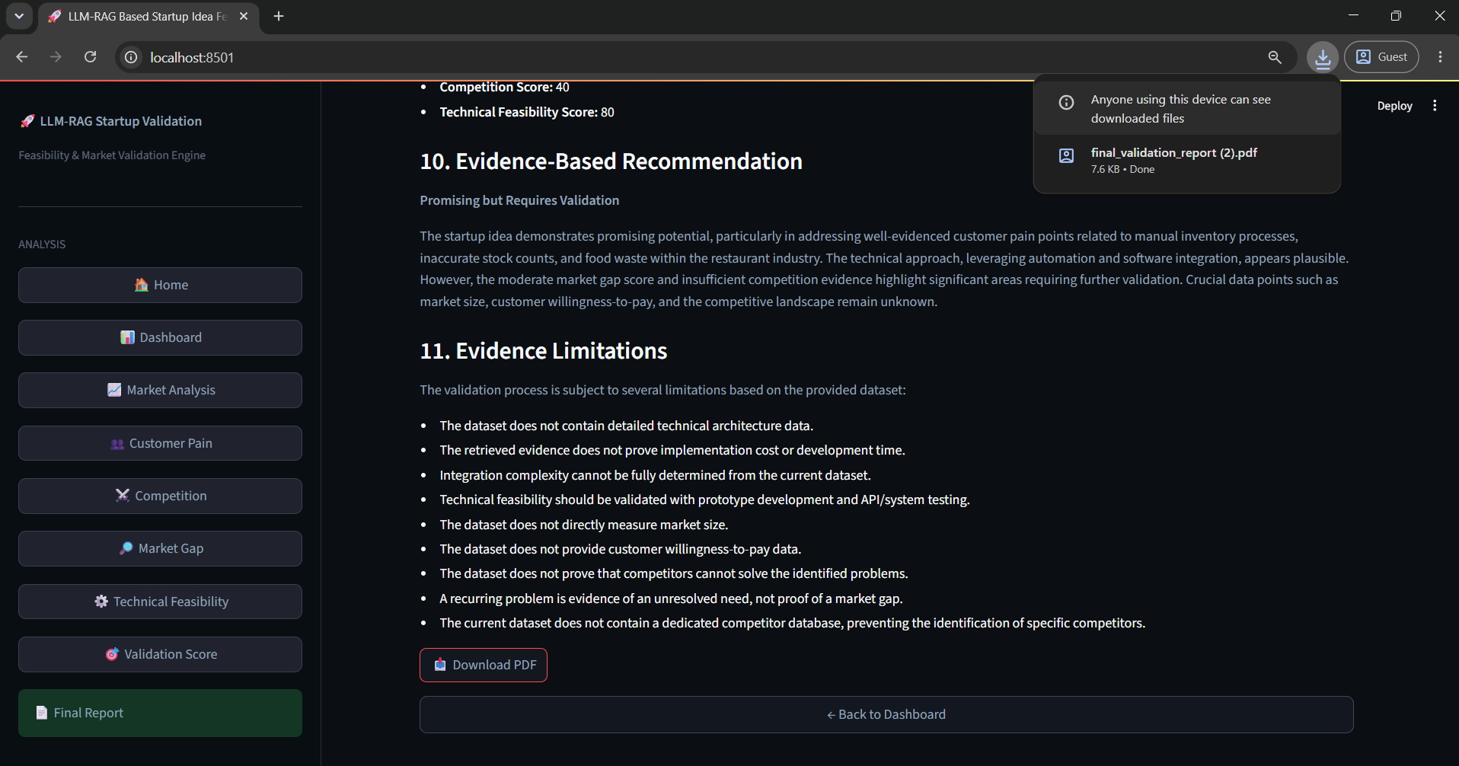
In the above screen the final section of the Startup Validation Report presents the Evidence-Based Recommendation and Evidence Limitations. The recommendation is generated using the analyzed evidence, while the limitations section describes the constraints of the available validation evidence.

